**Week 7 (29 Aug 2022 to 4 Sept 2022)**

**Unit 3.2 (Logic Gates) Homework**

1) Apply the laws of Boolean Algebra to reduce the circuit to it's simplest form

[10 marks]

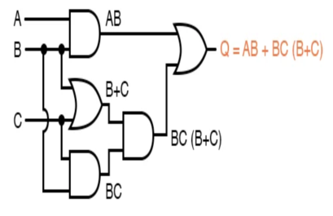

**AB+BC(B + C). A+A=A**

**=AB + BBC +BCC**

**=AB + BC**

**=B(A + C)**